# Colors in Java

When you use a setFill(), setBackground(), or any other method to tell Java what color you want to use, you have to put something in the brackets to specify the color. The thing you put in brackets will specify an existing color, or create a custom color for Java to use.

## Use a color name

Here are some examples…

c.setFill("red"); or

c.setBackground ("blue");

Possible color names include:

black, blue, cyan, darkgray, gray, green, lightgray, magenta, orange, pink, red, white, yellow

You can find a list of over 500 legal color names here: <https://www.w3schools.com/colors/colors_names.asp>

## You can specify red, green, and blue values for a New Color:

Here are some examples…

c.setFill("rgb(128, 138, 255)")*; or*

c.setBackground ("rgb(0, 100, 0)");

The three numbers specify how much of the colors red, green and blue to mix. 255 is the maximum amount, and 0 is the minimum. *rgb(0, 0, 0 )* is black, *rgb(255, 255, 255 )* is white, *rgb(255, 0, 0)* is bright red, *rgb(100, 0, 0)* is dull red, and so on.

## Finding the Color You Want

One way to do this is to go into word, then open the font color tool, select **more colors**, and the **custom** tab. Then choose the color you want, and copy down the red, green, and blue values shown.

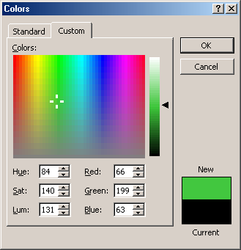

Choose color

Your color

Get red, green, and blue values